
HIGHLAND RIM HEAD START
P.O. Box 208 • 3215 Highway 149
Erin, Tennessee 37061
_____________________________________________________________________

Permission to Obtain or Release Confidential Information

I, «Parent_Name», give Highland Rim Head Start permission to obtain or release confidential information from various agencies or individuals regarding my child, «Childs_Name».

My consent, unless revoked in writing, is valid through June 30, 2019.

Information that may be requested or released may include, but is not limited to, the following:

Physical Exam/Records Dental Exam/Records
Lab/X-ray Results Immunization Records
Developmental Assessment Screening Results
Birth Certificate Social Security Number/Card
Health Insurance Card Individual Education Plan
Individual Family Service Plan Mental Health Records
Others as is necessary

__________________________ _____________________________
Signature of Parent/Guardian Signature of Head Start Staff

«Relationship» _____________________________
Relationship to Child Date

Phone 931.289.4135 • Fax 931.289.3220 • www.highlandrim.org

HIGHLAND RIM HEAD START
P.O. Box 208 • 3215 Highway 149
Erin, Tennessee 37061
_____________________________________________________________________

Program Permission Form

I HEREBY GIVE MY PERMISSION for my child to receive the examinations and services checked below. I understand that I will be notified in advance of the date and place of health services and that I may attend. I understand that I will be notified of the results of all screenings and assessments. I understand that all services will be provided free of charge to Head Start children and that parents will be contacted in advance if there is any charge for services. Head Start funds may be used for professional medical and dental services when no other source of funding is available.

Service Yes No
Dental Screening ___ ___
Dental Exam/Fluoride ___ ___
Hearing Screening ___ ___
Vision Screening ___ ___
Speech/Language Screening ___ ___
Developmental Screening ___ ___
Social/Emotional Screening ___ ___

IN ADDITION, I GIVE MY PERMISSION for the following: Yes No

For Highland Rim Head Start staff to visit my home during the ___ ___
school year (at my convenience) for home visits.

For my child to participate in field trips. ___ ___

For my child to participate in picture taking approved and ___ ___
supervised by Head Start Staff. (Some pictures may be
included on in-house publications and on social media sites)

For my child to be transported by Head Start staff to participate ___ ___
in any Head Start activity.

The above items have been explained to me. To the best of my knowledge, I have answered all the items correctly. I understand that I will be given advance notice before my child participates in any of the above activities.

___________________________ ___________________________
Signature of Parent/Guardian Signature of Staff Witness

Date: _____________________ Date: _____________________

Child’s Name: «Childs_Name»
Center: «Center»

Phone 931.289.4135 • Fax 931.289.3220 • www.highlandrim.org

HIGHLAND RIM HEAD START
P.O. Box 208 • 3215 Highway 149
Erin, Tennessee 37061
_____________________________________________________________________

Consent for Child’s Emergency Medical/Dental Treatment

I, «Parent_Name», hereby give my consent for needed emergency medical or dental treatment of the child listed below by any licensed physician or dentist while under the care of Highland Rim Head Start and for the transport of the child to and from the source of emergency treatment.

This care may include examinations and any test which, in the opinion of the physician or dentist, are deemed necessary or advisable.

This does not include the right to perform surgical operations without my consent, except in the case of an emergency when, after an effort has been made to locate me, I am found to be unavailable.

This consent is valid for the time period my child is enrolled in the Head Start Program.

The purpose of this consent form has been explained to me.

I have explained to, «Parent_Name», the purpose of this consent form.

«Childs_Name»
Name of Child
«DOB»
Date of Birth

Signature of Parent/Guardian
«Relationship»
Relationship to Child

_____________________________ __________________
Signature of Head Start Staff Date

Phone 931.289.4135 • Fax 931.289.3220 • www.highlandrim.org

Highland Rim Head Start
Family Partnership Agreement
and
Program Questionnaire
The Family Partnership Agreement is an opportunity for your family to build a positive relationship with the program staff on a volunteer basis, while identifying your family’s goals, and planning strategies for achieving your goals.


Students Name: «Childs_Name»
Parents Name: «Parent_Name»
Center: «Center»

_____ I agree to participate in the Family Partnership Agreement.

_____ I do not wish to participate in the Family Partnership Agreement at this time. I understand that if in the future, I would like to participate, I will be free to do so, and that my decision to not participate does not in anyway exclude me from receiving Head Start Family Services.

Parent Signature_________________________________ Date ______________________

Parents Name: «Parent_Name» Child’s Name: «Childs_Name»

Family Demographics
Parental Status: (circle one) One Parent Family Two Parent Family
Is your family homeless? Yes No
Were you referred to our program by a child welfare agency? Yes No
Is either parent a member of the United States Military? Active Duty / Veteran / None
Family Ethnicity: Primary Language:

 | At Enrollment | At End of Enrollment
Is any member of your family in foster care | Yes No | Yes No
Does your child receive a Child Care Subsidy? | Yes No | Yes No
Do you or anyone in your family receive:
Families First Benefits? | Yes No | Yes No
Supplemental Security Benefits? | Yes No | Yes No
WIC? | Yes No | Yes No
Supplemental Nutrition Assistance?  (SNAP/food stamps) | Yes No | Yes No
Education/Work History
Highest grade completed:
Are you currently in school? Yes No If yes, school’s name:
Present employment status: (circle one)
Unemployed Full Time Part Time Training Seasonal Retired/Disabled
Occupation: _______________________________________
Are you in a skills training or job related training program? Yes No
If yes, with salary? Yes No # Of hours per week: ________________________
Date began: ___________________ Completion date: ___________________________
Have you received any vocational, trade or business school training? Yes No
If yes, type: _______________________ Received certificate/license? Yes No
Did at least one parent/guardian complete any of the following during the program year?
Grade level (prior to high school graduation) Yes/No | High school or was awarded GED Yes/No
Associate Degree Yes/No | Baccalaureate or advanced degree Yes/No
Job training program, professional certificate, or license Yes/No
Male Involvement
During the school year did a father/father figure participate in the following?
Family Outcomes Assessment Yes/No | Family Goal Setting Yes/No
HS Development Experiences (HV, P/TC) Yes/No | HS Program Governance Yes/No
Parenting Education Workshops Yes/No

Parents Name: «Parent_Name» Child’s Name: «Childs_Name»

Family Services

Is your family in any specific need or crisis? _________________________
If so, please explain: ________________________________________
Do you or your family need assistance with any of the following services?
Food: (Nutrition, Pyramid, Safety, Labeling) YES / NO
Clothing: YES / NO
Transportation: YES / NO
Housing: YES / NO
Mental Health: (Stress Management) YES / NO
Literacy or Education: YES / NO
English as a Second Language: YES / NO
Adult Education: (GED, Adult Ed., Literacy) YES / NO
Job Training: (Job Search, Resume, Interview, Budgeting/Savings) YES / NO
Substance Abuse Prevention: YES / NO
Substance Abuse Treatment: YES / NO
Child Abuse or Neglect: (Detection and Reporting) YES / NO
Domestic Violence: YES / NO
Child Support YES / NO
Health Education: (Prenatal, Dental, CPR/First Aid, Communicable Diseases) YES / NO
Assistance to Families of Incarcerated: YES / NO
Parenting Education: (Parenting Skills, Stages of Development, Home Safety) YES / NO
Marriage Education: YES / NO
Asset Building Services: YES / NO

Health Services
Does your child currently have Health Insurance? YES / NO
If so, which type: (Circle one) TennCare CoverKids TriCare Private Other
Who is your child’s regular doctor? _____________________________________
Who is your child’s regular dentist? ____________________________________
Please circle all of the conditions below that your child is currently being treated for:
Anemia Hearing Vision Asthma Overweight High Lead Levels Diabetes

For Office Use Only:
Income Status: Eligible ___ Foster ___ Over Income ___ Public Assistance ___ 101-130% ___
Child’s enrollment year: 1 2 3
Needs Services: Yes/No Received Agency Social Services: Yes/No
Additional Community Services Needed: Yes/No Referred to Another Agency: Yes/No

ADDENDUM TO ENROLLMENT FORM FOR CHILD CARE

Highland Rim Economic Corporation
Name of Child Care Facility

Instructions: This Addendum may be used to meet the enrollment data requirements of the Child and Adult Care Food Program as mandated by the Interim Rule issued on September 1, 2004, by the U.S. Department of Agriculture. The Addendum will be valid for one calendar year following the date of the parent’s or guardian’s signature.

Participant Name: «Childs_Name»

Normal Days of Care (Circle as Appropriate):

Monday Tuesday Wednesday Thursday Friday Saturday Sunday

Normal Hours of Care during School Year: 8 to 2

________ to ________

Normal Hours of Care during summer: ________ to ________
(Through end of June only)
________ to ________

Participant Meals (Circle as Appropriate):

Breakfast AM Supplement Lunch

PM Supplement Supper Evening Supplement

Parent/Guardian Name: «Parent_Name»

Parent/Guardian Daytime Telephone Number: Area Code: _____ Number: ______________

___________________________________________ ________________________
Signature of Parent/Guardian Date of Signature

Keeping Kids Safe

Child’s Name: «Childs_Name»

“Keeping Kids Safe” is the personal safety curriculum used by our child care agency

Our agency uses another personal safety curriculum described below

Method of Instruction: _______________________________________________________________________

__________________________________________________________________________________________

__________________________________________________________________________________________

Sample Terminology: ________________________________________________________________________

__________________________________________________________________________________________

__________________________________________________________________________________________

The instructional materials used in the agency personal safety curriculum are available for review by the parents or legal guardians.

I/We acknowledge that we have been provided an opportunity to review the agency’s personal safety curriculum and been notified of the sexual abuse/personal safety curriculum for our child/children.

___________________________________________ __________
Signature of Parent or Legal Guardian Date

___________________________________________ __________
Signature of Parent or Legal Guardian Date

___________________________________________ __________
Signature of Agency Representative Date


STATE OF TENNESSEE
DEPARTMENT OF HUMAN SERVICES

PERSONAL SAFETY CURRICULUM NOTIFICATION FORM

Since 1985, Tennessee law has required that children in child care agencies receive annual instruction in personal safety, including child sexual abuse prevention. The personal safety curriculum shall include a Department-recognized component on the prevention of child abuse.

Public Chapter 1032 passed by the General Assembly in 2008 requires that child care agencies have a personal safety curriculum, including a child sexual abuse component, for children enrolled in the agency, and that parents/legal guardians be informed about the curriculum, methods and terminology that will be used in teaching children about personal safety. The Department of Human Services was directed to provide guidelines for this curriculum, but individual child care agencies may choose a curriculum that accomplishes the same goal, and may use different terminology in the curriculum. The child care agency is required to allow parents/legal guardians to review and ask questions about the curriculum, and to meet with representatives of the child care agency if they have questions.

In addition, the child care agency must obtain from parents/legal guardians a form acknowledging that they have been notified of the child sexual abuse/personal safety curriculum being used by the child care agency in which the child is enrolled. A copy of the form is required to be maintained in the child’s record.

“Keeping Kids Safe” is the sample personal safety curriculum offered by the Department. This curriculum takes a holistic approach to the safety of children. The curriculum is composed of the following units: Self Esteem, Family & Friends, Feelings, Problem Solving, Personal Safety (general) and Personal Safety (4-5 year olds), and Safety Around Me. All sessions begin with group time and are followed by supplemental activities that give children additional practice in understanding the concepts. The curriculum uses hand puppets to serve as a group motivator and to introduce the stories. Together staff and parents decide what terminology to use when referring to the genitals, either the correct anatomical terms or the general term “private body parts.”

HEALTH HISTORY

Hospitalizations and Illnesses | Yes | No | Explain “Yes” Answers
Has your child ever been hospitalized or operated on? Explain
Has your child ever had a serious accident or injury? Broke Bone? EXPLAIN
Health Problems |  |  | Explain “Yes” Answers
Does your child have:  ______Medical Home ______ Dental Home |  |  | Medical Provider:______________________________________________  Dental Provider:______________________________________________
Does child have problems with ears/hearing (pain in ear, frequent earaches, infections, drainage, hearing loss)?  __YES* ___NO |  |  | Medical Provider: ____________________________________________  *Date last seen: ______________________________________________
Has child ever had a convulsion or seizure?  If yes, was seizure/convulsion related to high fever? √  ___YES ___NO |  |  | *Medical Provider:____________________________________________  Date last happened: ___________________________________________  Type of medication? __________________________________________
Is your child taking any medications? ** |  |  | Type of medication? __________________________________________  Reason for Medication: ________________________________________  ____________________________________________________________
Does the child or immediate family members have any of the following health concerns, specify which: *√  ____Asthma ___Bleeding Tendencies  ____Diabetes ___Heart/Blood Vessel Disease  ____Liver Disease ___Sickle Cell Disease  ____Other(explain): ___ Chronic Condition ____________________________________ |  |  | Child's  Medical Provider: ____________________________________________  Date last seen: ______________________________________________
Does your child have frequent:
- Urinary infections or trouble urinating, or
Stomach pain, vomiting, diarrhea? EXPLAIN

Does your child have a diagnosed disability, with an IEP/IFSP?EXPLAIN |  |  | Provide copies of IEP/IFSP, or any documentation regarding the diagnosis.
Are there any conditions/treatment/care that has not been discussed that may affect your child while at school? **
If Yes explain

Child’s Name: «Childs_Name» DOB: «DOB» Center/Classroom: «Center»

*Complete Release of Information ** Release of Information may be needed √Complete Individualized Health Action Form

PHYSICAL, PHSYCHOLOGICAL, AND SOCIAL DEVELOPMENT

These questions will help us better understand your child. Would you tell me one or two things your child is interested in or does especially
well?

How does your child tell you he/she has to go to the restroom? Explain:
_________________________________________________________________________________________________________________

Does your child need help with using the bathroom? €YES €NO

If yes, explain: _________________________________________________________________________________________________________________

How does your child respond to adult he/she does not know?

Does your child have any difficulties saying what he/she wants to do or do you have any trouble understanding your child? Explain

__________________________________________________________________________________________________________________

Have there been any recent changes or problems in your child’s life that may affect your child’s behavior? €YES €NO If yes, explain:

__________________________________________________________________________________________________________________

Do you have any concerns regarding your child’s behavior? €YES €NO If yes, explain:

NUTRITION
How would you describe your child’s appetite? € Good €Fair € Poor

Any recent changes in appetite? €Yes € No If yes, explain: ___________________________________________________________

How does your child react when introduced to new foods? _________________________________________________________________
Does your child choke or gag on food? €Yes €No
Does your child eat things that are not food? €Yes €No If yes, explain _________________________________________________

Is your child on a special diet due to religious/medical reasons? €Yes** €No If yes, explain:___________________________________
__________________________________________________________________________________________________________________
Diagnosed with a food allergy or non-food allergies? €Yes** €No If yes, explain: _____________________________________________
________________________________________________________________________________________________________________
Does your child feed him/herself? €Yes €No If yes, how?
___Eats with fingers ___Uses fork/spoon ___ Uses regular cup/glass
*Complete Release of Information ** Release of Information may be needed √Complete Individualized Health Action Form

Parent/Guardian Signature: ______________________________ Date: ___________

Staff Signature: _______________________________________ Date: ____________
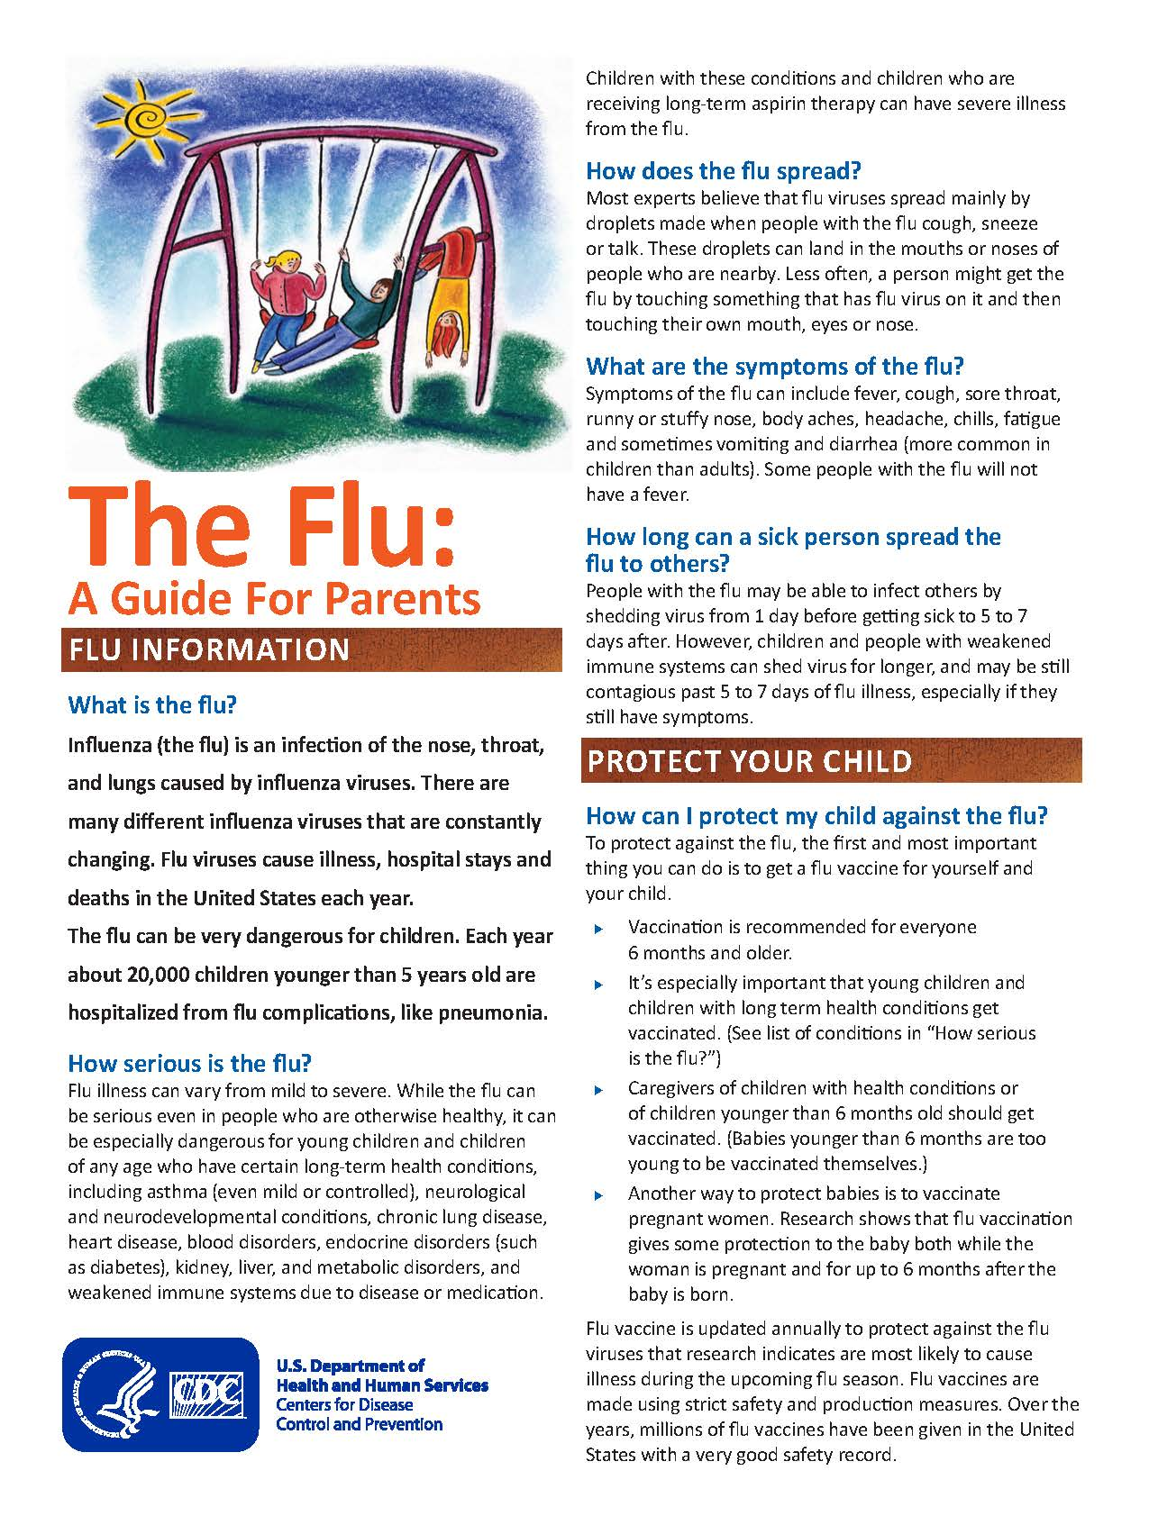
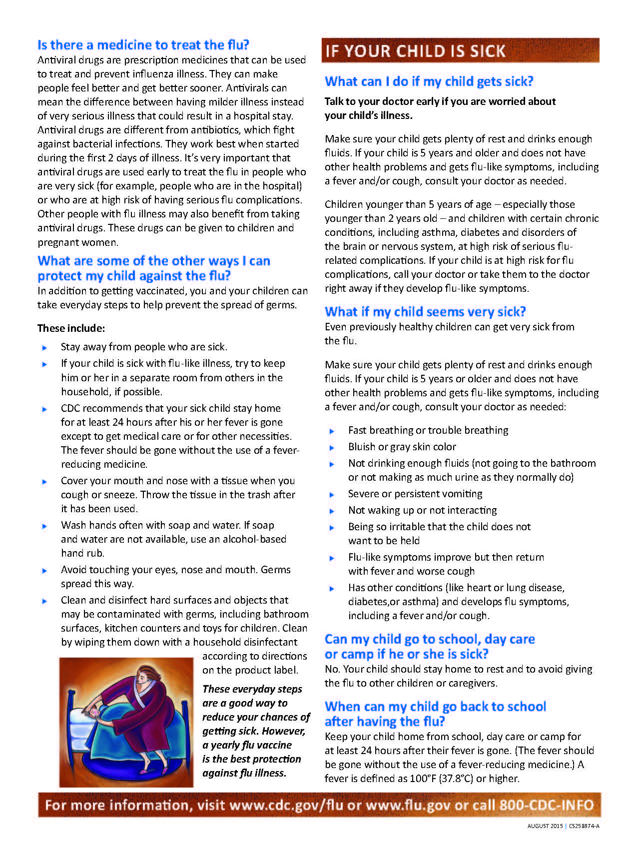
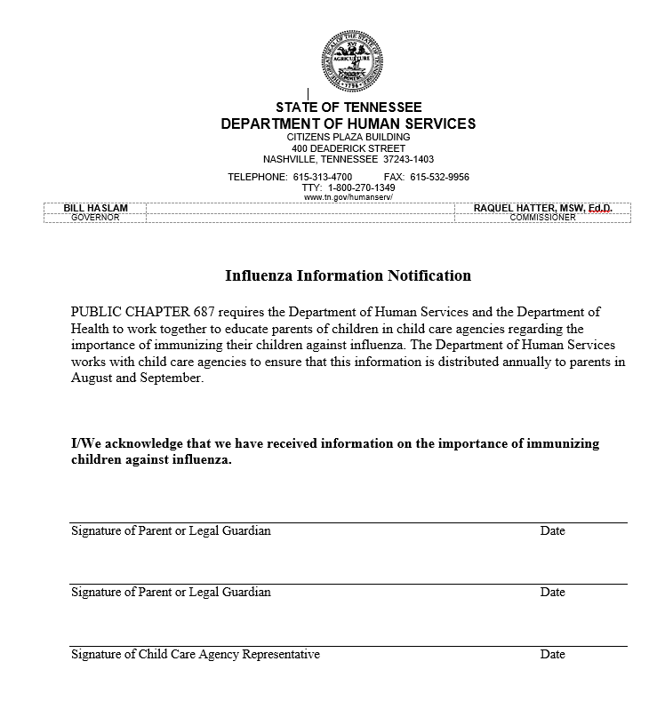
HIGHLAND RIM HEAD START PROGRAMS FAMILY GOAL SHEET

CHILD’S NAME: «Childs_Name»

Goal from FPA

Objectives (steps to achieve the goal) | Expected Completion Date: | Completion Date | Comment

FAMILY SIGNATURE: _______________________________ DATE: ________________

FSW SIGNATURE: _________________________________ DATE: _________________

GOAL

DATE ACHIEVED: __________________________ DATE NO LONGER A GOAL: ______________________________

